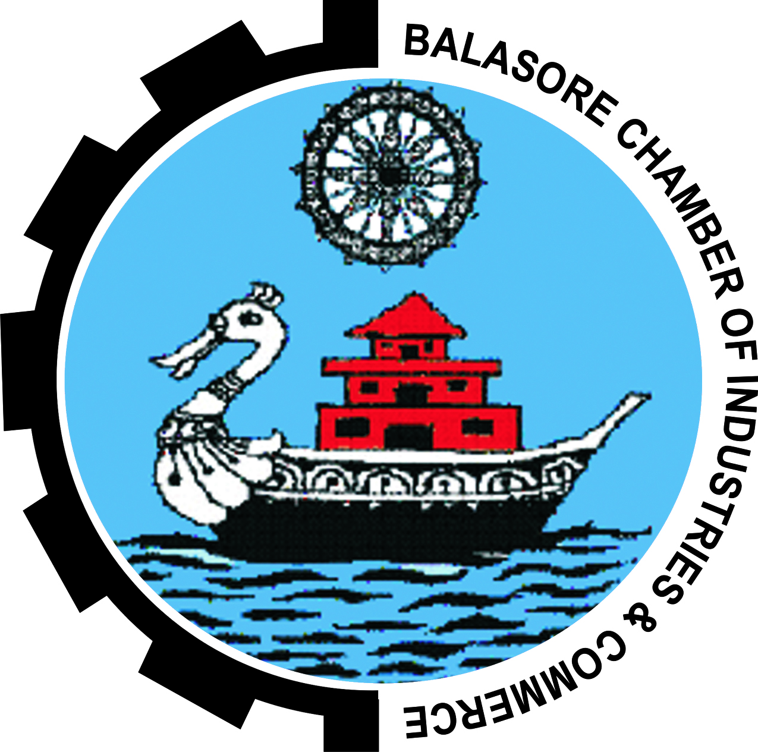
BCIC
BALASORE CHAMBER OF INDUSTRIES & COMMERCE

UDYOG BHAWAN, INDUSTRIAL ESTATE, BALASORE – 756001, ODISHA
Ph. No. – 06782 – 240804/263030, Fax – 06782 – 263060,
Email – bcic@bcicbalasore.org, web: - www.bcicbalasore.org

Volume – I, Issue – II Date: - 01.04.2016
Activities from January – March 2016

BALASORE CHAMBER OF INDUSRIES AND COMMERCE is now a 25 years youth functioning continuously in promotion of enterprises in and around Balasore. It is also participating in district social and cultural developments, policy making, and Natural calamities. During this period, out of the many the major achievements are establishment of ICU in district medical, development of the railway storage yard, platform, over bridge, modification of Foot Bridge, modernization of Gandhi Park, setting up Plastic Cluster & Rice Cluster at Balasore and having its own office building. Further, the Chamber is a Member of different policy making committees of the both State & Central Governments. It has been affiliated to CII, UCCI, World Trade Center, Bengal Chamber of Commerce and Industry and Council of Small Scale Industry. The Chamber is also the approved training center of NCVT, OKCL and Pradhan Mantri Kausal Vikash Yojana. The Chamber is now became broad based by adopting trade, commerce and service sector to its member and accordingly modified its By-Law. It has increased its strength from 23 Members during 1989 to 210 by 2015
To add its credit, the Chamber is organizing continuously Industrial Exhibition and trade Fair (EXPO ODISHA) since 2004 in association with either MSME Development Institute, Govt. of India, NSIC, District Administration, Industries Department , Department of Cottage & Handicraft or all of them which is become a crowd pulling event of the district and benefitted the Industries, Cottage & handicraft Artisans, Trade & Commerce establishments, Service providers, Educational Institutions, Self Help Groups of the state and adjacent States. This event also encouraged new and prospective entrepreneurs for their self employment.
This is only possible due to the active participation of its Members in all its activities and organizing these successfully. Thanks to all Members of the Chamber for their support & Patronage to bring the Chamber to this stage and celebrated its Silver Jubilee Year-2015.

Er.Bharat Charan Swain
Executive Director
Important Message | DIGITAL LUNCH OF EMPLOYMENT EXCHANGE FOR INDUSTRIES (EEX)  Digital Lunch of Employment Exchange for Industries (EEX) is lunched by Hon’ble Union Minister, Sj. Kalaraj Mishra, Ministry of Micro Small & Medium Enterprises, Government of India on 15th June’2015. This is a step towards linking “Make in India” with skilled India. This shall be exchange for employer and job seekers register at www.eex.dcmsme.gov.in . This will facilitate both the employers and job seekers being registered online.  UDYOG AADHAAR MEMORADUM  Government of India has lunched Udyog Aadhaar Memorandum for registration of Industries. Now there is no necessity to file EM-II & EM-I for registration of Industries. It is now linked with Udyog Aadhaar. Entrepreneurs are to file online in the prescribed one page Udyog Aadhaar form only. A one page format has been devised for the same can be available on the web side.  ‘SCHEME FOR PROMOTION OF INNOVATION, ENTREPRENUERSHIP AND AGRO-INDUSTRY”  The scheme is approved by Government of India on 11.03.2015 and proposed to set up, a fund with corpus of about Rs. 200 crores to establish Technology Center Network to promote innovation, entrepreneurship and Agro-Industry. It was also proposed to lunch a program to facilitate toward and backward linkage with multiple value chain of manufacturing and service industry and a Nationwide “District level Incubation and Accelerator Program” for Incubation of new ideas and providing necessary support for accelerating entrepreneurship.
22.01.2016  22.01.2016  22.01.2016 | BALASORE MAHOTSAV, PALLISHREE MELA & EXPO ODISHA-2016.  As per detail discussion with Director MSME Development Institute, Government of India, Cuttack, District Administration and District Industries Center, Balasore the date for organizing this event was finalized to organize BALASORE MAHOTSAV, PALLISHREE MELA & EXPO ODISHA-2016. During 22ND to 26th January 2016 and accordingly a organizing Committee was constituted under the Chairmanship of the Collector, Balasore and Balasore Chamber of Industries and Commerce has been given responsibility to do all arrangement to make it a success. Accordingly the program was organized from 22ND to 26th January’2016 at ITI Field, Balasore.
INAUGURAL DAY

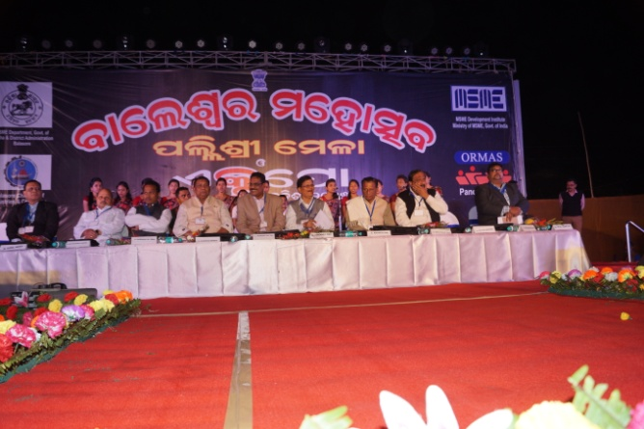
The program of BALASORE MAHOTSAV, PALLISHREE MELA AND EXPO ODISHA-2016 was inaugurated by Hon’ble Minister of MSME Department, Govt. of Odisha Sj. Jogendra Behera, Chief Guest of the occasion, by lighting the lamp before LORD JAGANNATH in presence of Sj. R.K. Jena, MP, Balasore, Sj. Ananta Das, Chief Whip, Govt. of Odisha, Sj. Jiban Pradeep Dash, MLA, Balasore Sadar, Sj. Nityanand Sahoo, MLA, Basta, Sj. Sukanta Kumar Nayak, MLA, Nilagiri,. Sj. P.K. Gupta, Director, MSMEDI, Govt. of India, Cuttack, Sj. Pramod Kumar Das, Chairman of Mahotsav Committee & Collector and District Magistrate, Balasore, Sri Himanshu Das, President, BCIC, Sj. Sunil Modi, General Secretary, BCIC. After lighting of lamp the Chairman of the Mahotsav Committee Sj. Pramod Kumar Das, Collector and District Magistrate has presided over the meeting and well come all the Guests, participants and gathering for their overwhelming support to make the program a great success. Sj. P.K. Gupta, Director, MSMEDI, Govt. of India, Cuttack has given a brief note of the event.
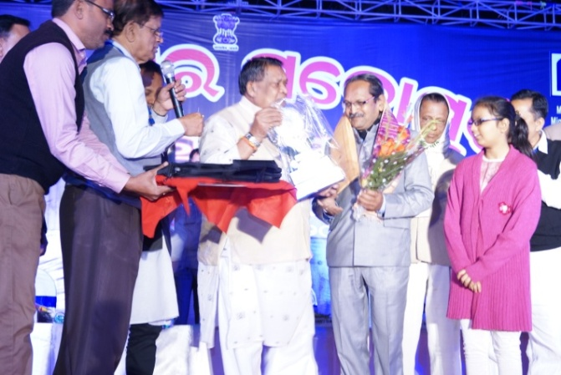
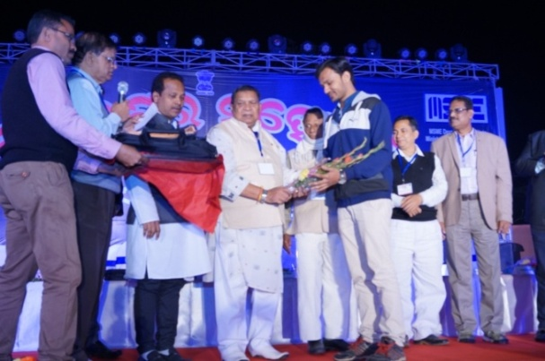
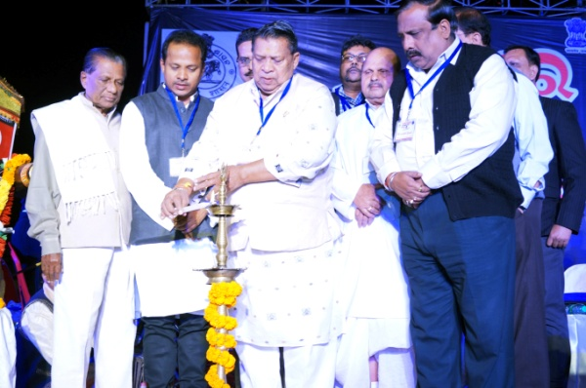
Sj. Himanshu Das, President, BCIC, address the participants in the program and expressed his happiness for such grand program. He stressed that this program definitely improve the health of the industry, artisans, Self Help Groups, business establishments, service providers and government departments who have participated in this event and encourage the young mass to learn how a person can do such undo things for his/her lively hood. All the MLAs have presented the overall picture of the country’s growth in industry sector and what is the position of Balasore. They stressed that there is ample scope of promotion of enterprises in Balasore and requested all to utilize the resources and avail the Government promotional schemes to set up their ventures which not only create employment but also add to the GDP of the Nation. Further they also pointed out the various aspect of enterprise promotion in the district by these events. On this occasion BCIC has Awarded Sri Ratilal Patel, Nilachala Concrete Product, Sri Rambabu Khandelwal of S.L. Gupta & Sons for their Lifetime Achievement in enterprise promotion, along with Cables (India) Pvt. Ltd. For Excellent Performance in Industry Sector since 1976 & Tirtharaj & Co., for Excellent Performance in Trade Sector since 1954. They have received Momento, Shawl & Certificate from Hon’ble Minister of MSME Sj Jogendra Behera. The Hon’ble Minister Sri Jogendra Behera has briefed the Industrial Policy Resolution and other promotional programs of the State Govt. and stated that Balasore is the most potential district for promotion of not only Industry, Agriculture, Tourism and fishery sector. Govt. has is supporting MSMEs for their sustainable growth. Entrepreneurs should avail the opportunity of this. Sri Sunil Modi, General Secretary of the Chamber presented vote of thanks to all. Then cultural program was performed by eminent artist.
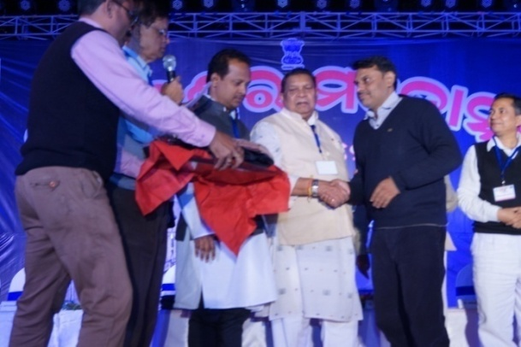
23.01.2016  23.01.2016 | 2nd Day EVENTS-EXPO ODISHA-2016  One day Seminar on MUDRA YOJANA:  One seminal was organized by MSME-DI, Govt. of India, Cuttack in association with Balasore Chamber of Industries and Commerce in the conference hall of the Exhibition on MUDRA YOJANA of as announced by The Prime Minister of India. Sj. P. K. Gupta, MSMEDI, Cuttack presided over the program. Resource person from MSMEDI, Cuttack has presented all aspects of the scheme which has implemented in whole of the country. Banks are given the target to help the needy entrepreneurs for setting of enterprises. Sj. Gupta encouraged the youths to avail this golden opportunity not only for their livelihood but also create job opportunity for the others.  B to B meet on Ancillary Units.  In the afternoon, one to one interaction with the authorized officers from NALCO, MCL, ORDNANCE FACTORY &NINL was also organized in the same conference hall. The local MSMEs have detail interaction with theses officials to be a ancillary unit of the mother plant.
2nd Day Evening-EXPO ODISHA-2016

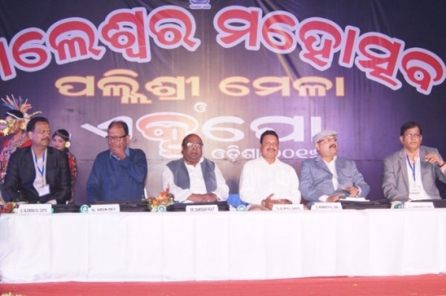
In the evening a meeting was organized under the Chairmanship of Sri Himanshu Das, President of the Chamber. Sj. Damodar Rout, Minister for Excise & Cooperation, Govt. of Odisha grace the occasion as Chief Guest. Among other Honorable Guests are Sj. Alok Kumar Sahoo, Chairman, Balasore Municipality, Sj Manmath Kumar Pani, Additional District Magistrate, Balasore, Sj. Arun Dey, Ex-MLA, Balasore. The Guests presented different aspect how Balasore district promoted to develop one Industrially and also Agriculture. The Chief Guest has given a detail story of the State starting from Business through Ships with Java & Sumatra till the promotion of the state in various sector. Sri Rajendra Gupta, Secretary (Industry) of the Chamber presented vote of thanks to all. Then cultural program was performed by the artists.
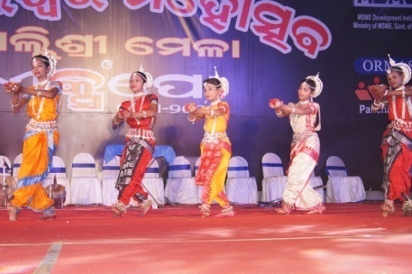
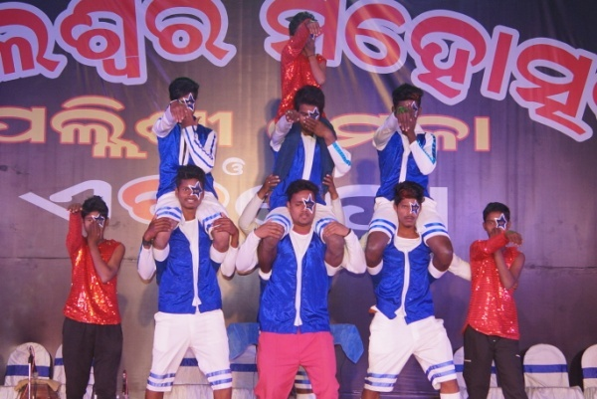

24.01.2016 | 3rd Day Evening - EXPO ODISHA-2016  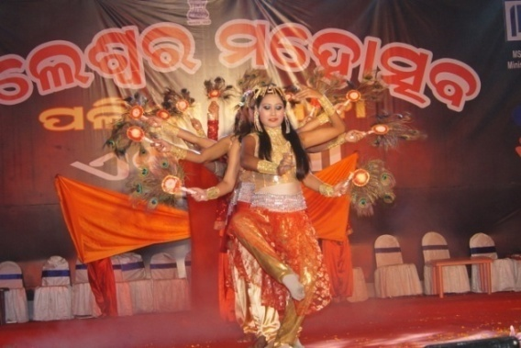  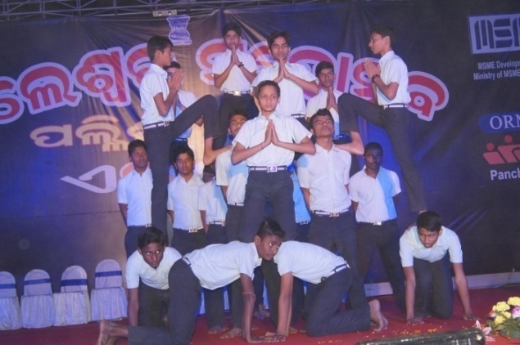  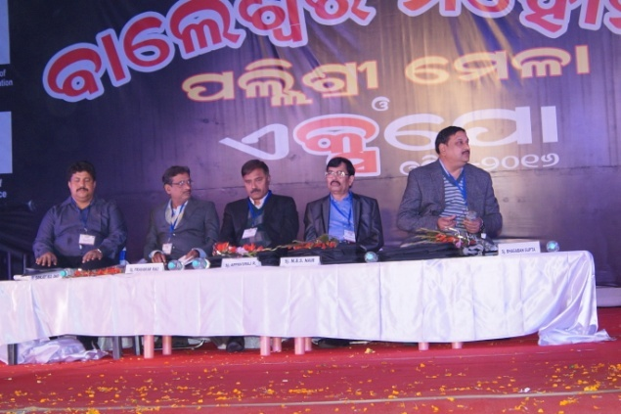  A Meeting was organized in the evening with Sj Appvuraj R., Director, PXE, Chandipur as Chief Guest. Sj. Bhagaban Gupta, Vice President of the Chamber presided over the meeting and well come all. Other Hon’ble Guests are Sj. P. Pravakar Rao, General Manager, DIC, Balasore, Sj. M.B.S. Nair, Director (Operation), Emami Paper Mills Ltd., Balasore, Sj. P. Pravakar Rao presented what is the role of DIC and what facilities rendering for promotion of enterprises, Sj. M.B.S. Nair stressed up on the how Emami Paper Mill is helping the local entrepreneurs and society for their economic growth. If any entrepreneur take up any by product and start his unit, he is there to help him. Sj. Appavuraj Chief Guest stressed up on the benefit availing the local entrepreneur from PXE and MSME-DI, Cuttack is organizing Vender Development meet at PXE also appreciated the effort of organizing this grand event within many odds. He further told that this program will definitely improve the further development of the district .Sri Sanjay Das, Secretary (Industries & Trade) of the Chamber presented vote of thanks to all. Then cultural program was performed by the artists.
4th Day Evening-EXPO ODISHA-2016

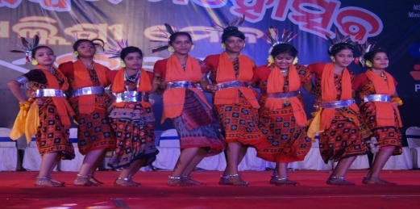
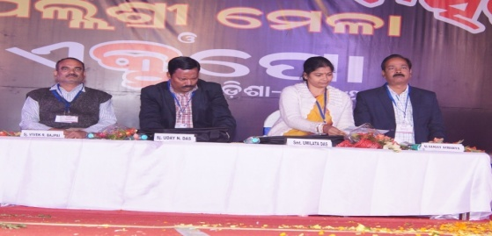
In the evening, a meeting was organized under the Chairmanship of Sj. Sanjaya Acharya, Vice-President (Industry) of the Chamber. Smt. Umilata Das, President, Zilla Parisad, Balasore graced the occasion as Chief Guest and Sj. Uday Narayan Das, Project Director, DRDA, Balasore was the Hon’ble guest. Smt. Das presented the role of woman in the development of the society and over all the country. She found lot of products is here by the woman self help groups. This shows how the women can work for their livelihood. Sj. Das, the Hon’ble Guest appreciated the arrangement of the grand programme properly and encouraged the participant to learn what developments can be done in their products through interaction with other participants. Sj. Vivek Raj Bajpai, Joint Secretary (Planning) presented vote of thanks to all. Then Cultural program was performed by the artists.
26.02.2016 | CLOSING DAY CEREMONY OF EXPO ODISHA 2016  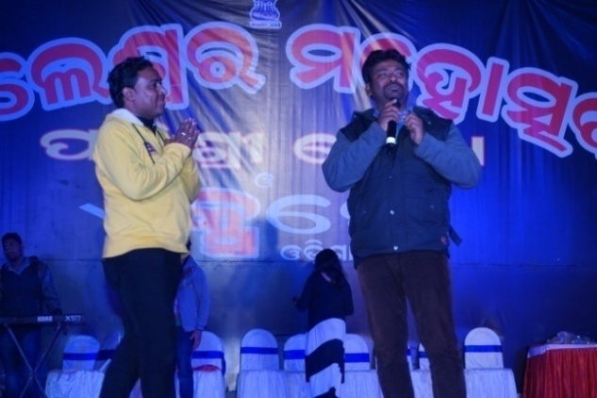  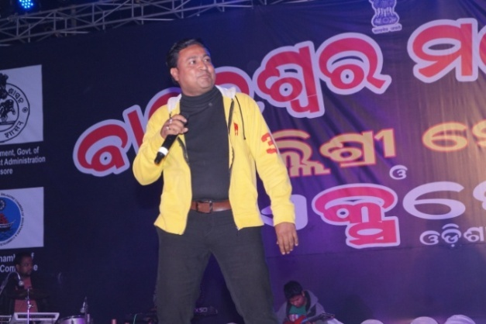  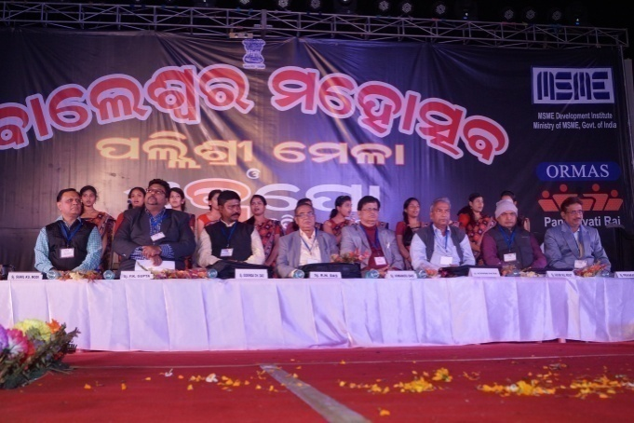  A meeting was organized in the evening to give a finishing touch of the event. This valediction day was graced by Sj. Rabi Narayan Das, IAS (Retd.), Advisor, State Planning Board, Govt. of Odisha, as Chief Guest .Among other Hon’ble Guests are Sj. Gobinda Chandra Das, MLA, Remuna, Sj. Aswini Patra, MLA, Jaleswar, Sj. P.K. Gupta, Director, MSME-DI, Govt. of India, Cuttack, Sj. P. Pravakar Rao, General Manager, DIC, Balasore, Sj. Gouri Kumar Rout, Chairman, BRIT, Balasore. The Meeting was presided over by Sj. Himanshu Das, President of the Chamber. Sj. Himanshu Das well come all the Guests and others while Sj. P.K. Gupta presented the key note address of the event. The guests have spoke on the occasion and appreciated the program which will be an eye opener to the prospective entrepreneurs. Sj. Das, the Chief Guest presented a wide range of objectives how Gujrat has improved and there is such facilities are there. So Balasore should rise to the occasion to improve a lot to compete globally. Then prize awarding ceremony was organized. The participants who has shows proficiency are being selected for prize by a team of officers in the selection board. Sector wise prizes are awarded as given below. Lastly vote of thanks has been presented by Sri Sunil Modi, General Secretary of the Chamber. Cultural program was performed by the artist. There by five days program has come to an end.

AWARD CEREMONY IN CLOSING CEREMONY
CATEGORY | NAME | PHOTO
BEST DISPLAY  (Small Scale Industries)  Neelachal Furniture Pvt. Ltd. | 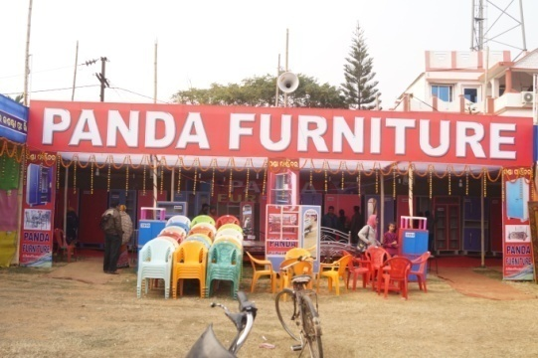 | 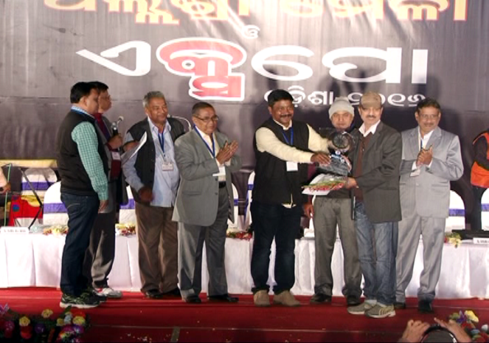  Sri Prafulla Ku. Panda, MD of Neelachla Furniture P.l. receiveing Certificate & Trophy from Sj. Gobinda Ch. Das, (MLA, Remuma)
BEST DECORATION  (Small Scale Industries)  Raja Fly Ash Bricks | 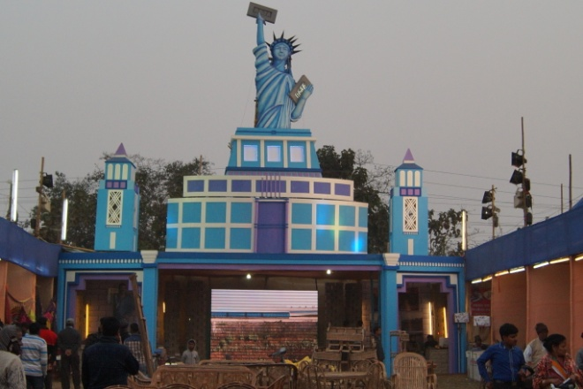 | 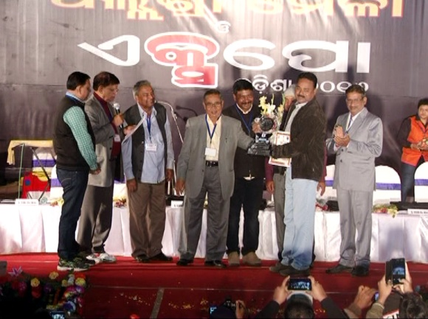  Sri Raju Gopal Sahu, MD of Raja Fly Ash Bricks receiveing the Certificate & Trophy from Sj. R.N. Das, IAS (Retd.)
BEST DISPLAY  (TRADE & COMMERCE)  Supratik Infraventures | 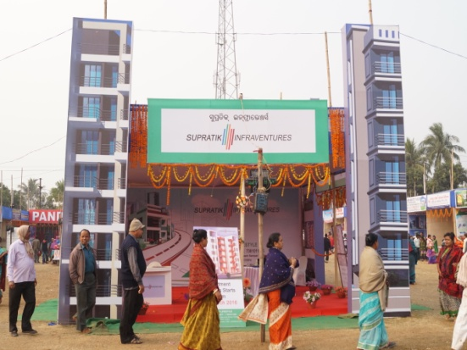 | 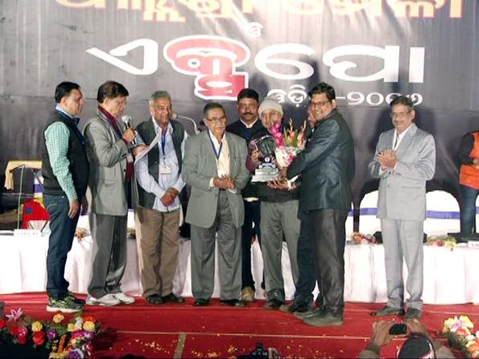  Representatives of Supratik Infraventures receiving Certificate & Trophy from Sj. R.N. Das, IAS (Retd.)
BEST DECORATION  (TRADE & COMMERCE)  Videozone | 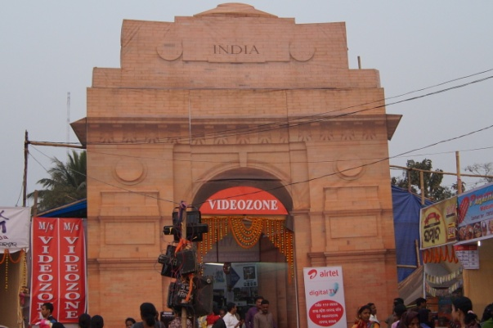 | 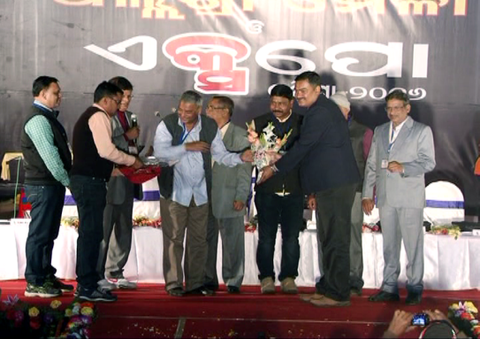  Sri Ayen Sen, Proprietor of Videozone receiveing the Certificate & Trophy from Sj. Aswini Patra, MLA (Jaleswar).
BEST DISPLAY  (4 WHEELER CATERGORY)  Premier Hyundai | 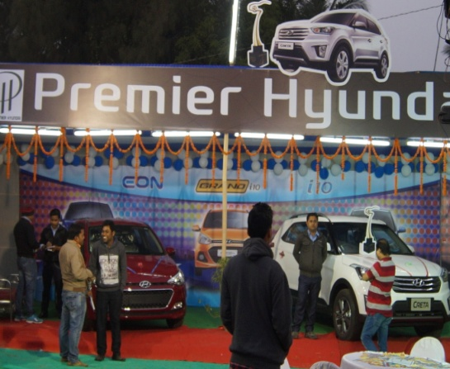 | 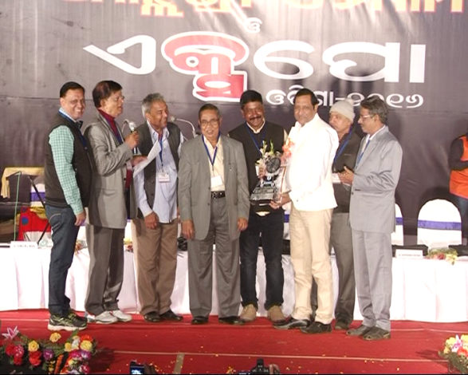  Sri Shibu Poddar, MD of Premier Hyundai receiveing the Certificate & Trophy from Sj. R.N. Das, IAS (Retd.)
BEST DISPLAY  (2 WHEELER CATERGORY) | Neelam Hero | 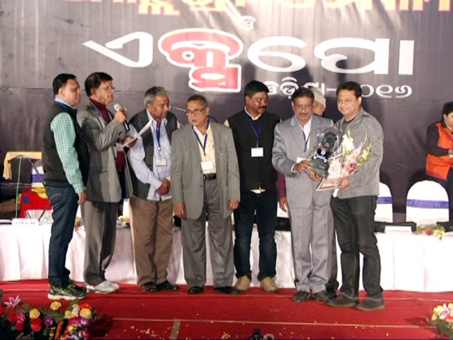  Sri Manish Saraogi, Director of Neelam Hero receiving Certificate & Trophy from Sj. P. Pravakar Rao, GM, DIC, Balasore.
BEST DISPLAY  (SWACHHA BHARAT ABHIYAN)  Balasore Municipality | 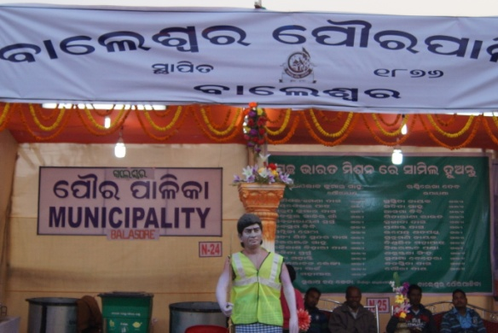 | 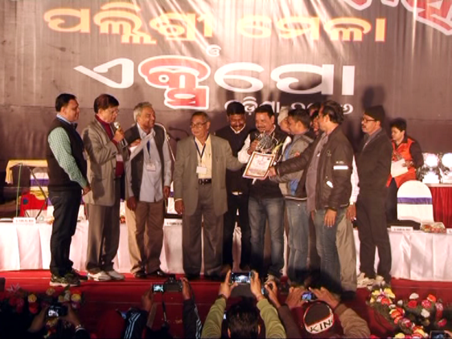  Sri Alok Sahu, Chairman of Balasore Municipality along with other Staff receiveing the Certificate & Trophy from Sj. R.N. Das, IAS (Retd.).
BEST DISPLAY  (GOVT. SCHEMES)  Dy. Director, Horticulture, Balasore |  | 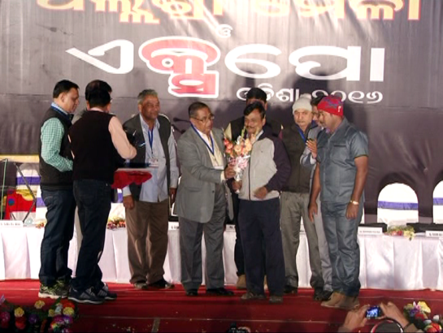  The Representatives of Horticulture Dept., Balasore receiving Certificate & Trophy from Sj. R.N. Das, IAS (Retd.)
BEST DECORATION  (HOTEL )  Barjorji’s Hotel Pvt. Ltd. | 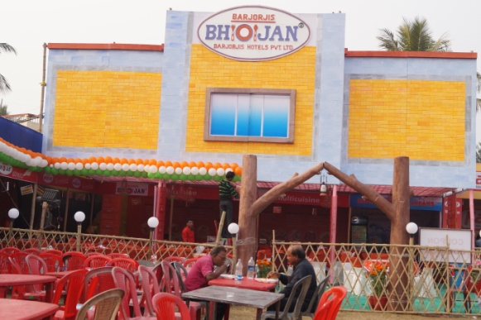 | 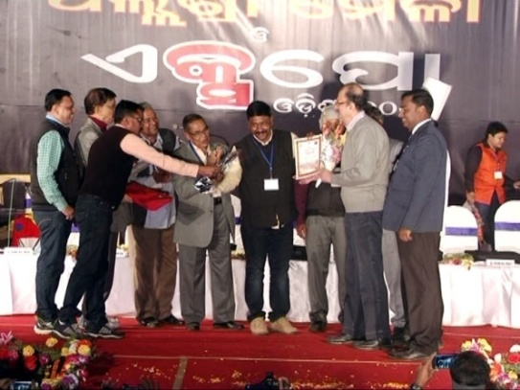  Sri Malcolm Bodhanwala, Director of Barjorji’s Hotel P.L. receiving the Certificate & Trophy from Sj. Gobinda Ch. Das (MLA, Remuna)
BEST DECORATION  (HOTEL )  Hotel Hariplaza | 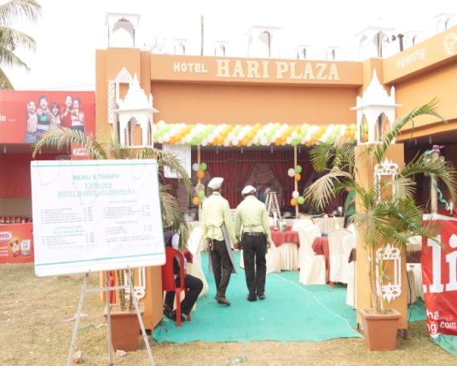 | 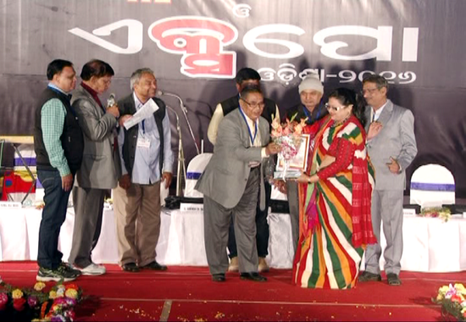  Smt. Aliva Das, MD of Hotel Hariplaza receiving the Certificate & Trophy from Sj. R.N. Das, IAS (Retd.).
BEST CSR ACTIVITIES  Balasore Alloys Ltd. | 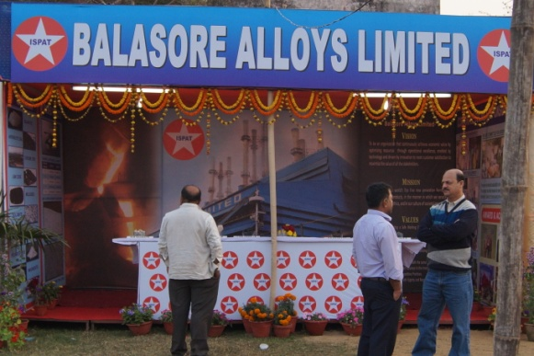 | 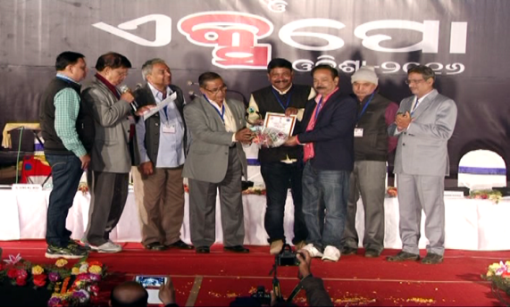  Sri Sanjay Acharya, of Balasore Alloys receiving the Certificate & Trophy from Sj. R.N. Das, IAS (Retd.).
BEST CSR ACTIVITIES  Emami Paper Mills Ltd. | 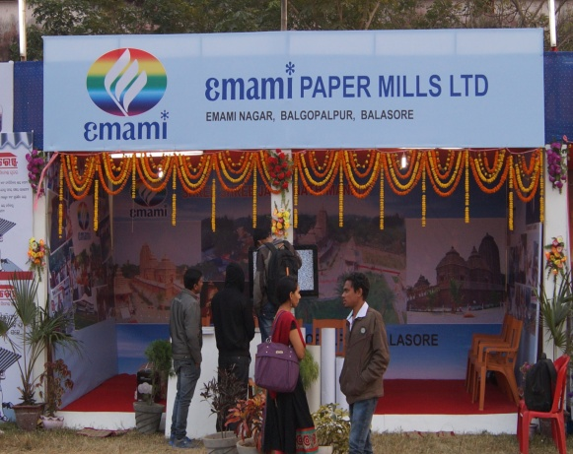 | 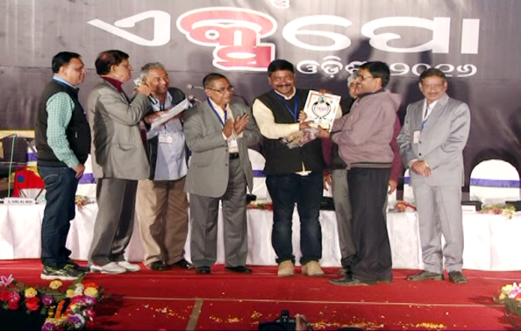  Sri Manoj Padhi, of Emami Paper Mills Ltd. receiving the Certificate & Trophy from Sj. Gobinda Ch. Das (MLA, Remuna)
EXCELLENT PERFORMANCE  (SWACHHA BHARAT ABHIYAN) | Karni Thermoplast Pvt. Ltd. | 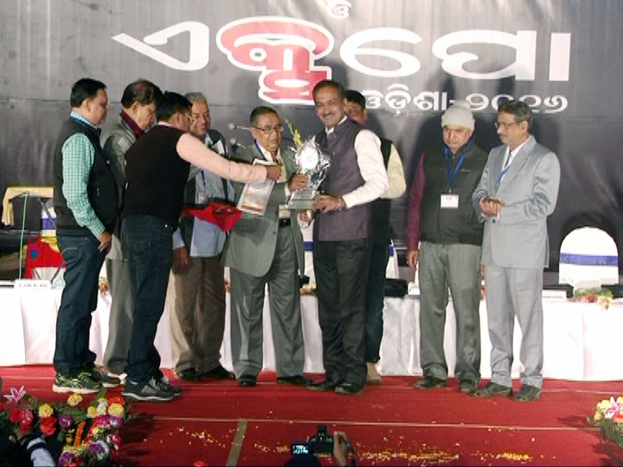
EXCELLENT PERFORMANCE  (Best Cultural Programme Coordinator) | Chinmay Biswal | 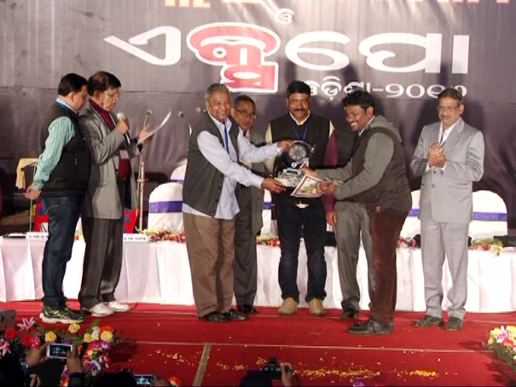
EXCELLENT PERFORMANCE  (OFFICE MANAGEMENT) | Radhanath Rath | 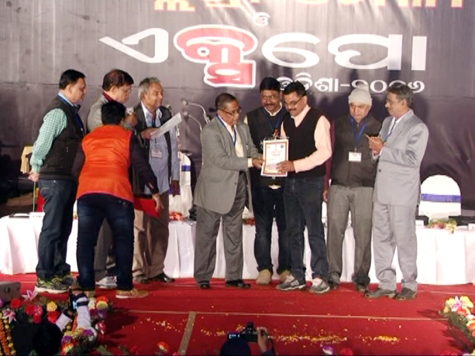

01.11.2015 | SEMINARS & events  ANNUAL GENERAL BODY MEETING OF THE CHAMBER  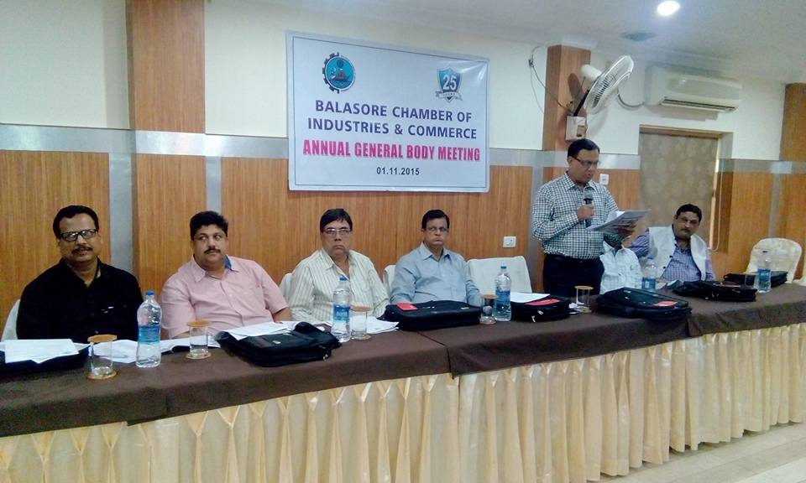  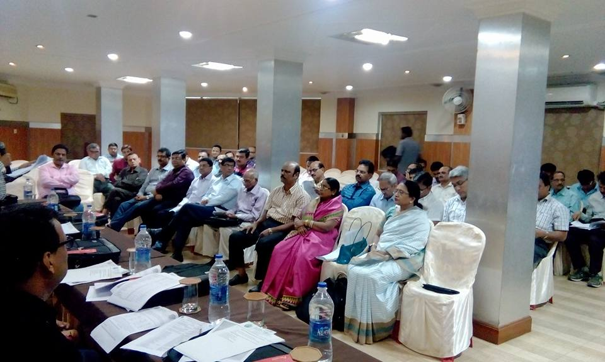  Annual General Body Meeting of the Chamber was organized in the conference hall of the Hotel Hari Plaza on 1ST November’ 2015. Sri Himanshu Das presided over the meeting and expressed his happiness on the overwhelmed support of all the members and their involvement in all the activities to bring the Chamber at this stage. The Chamber is celebrating the Silver Jubilee which is the pride of all of us. Besides the normal agenda of approval of the proceeding of last meeting, Audit Report of the chamber for the year 2014-15, induction of new members etc, the matter of organizing the EXPO ODISHA-2016 was discussed in detail and decided to make the same during last week of January’2016 as there will be examination session of the students of various disciplined. The Executive is authorized to take action accordingly. Sri Sunil Modi, General Secretary presented vote of thanks to all members.
01.11.2015 | CELEBRATION OF SILVER JUBILEE YEAR OF THE CHAMBER-2015  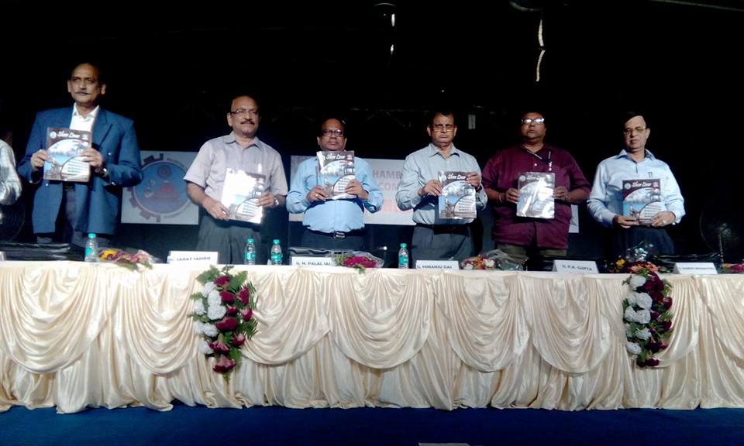  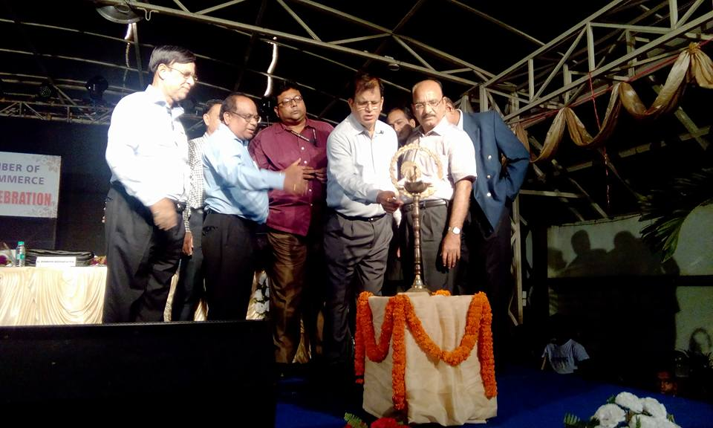  The Silver Jubilee function was celebrated at Hotel Hari Plaza on the evening of 1st November ’2015 under the chairmanship of Sri Bishnu Maroo, Chairman of Silver Jubilee. Among the Guests Sj. N. Palai, IAS, Director of Industries, Odisha, Sj. P.K.Gupta, Director, MSMEDI, Govt. of India, Cuttack, Si. Ramesh Mohaptra, President, UCCI, Bhubaneswar, Sj. Srat Sahu, Presient, Odisha Industries Federation, Cuttack & Sj. Abani Kanungo, President, Odisha Industries s Association were present. The Chief Guest Sri Nityananda Palai,IAS inaugurated the program by lighting the lamp in presence of all guests and participating members and their family. Sri Bishnu Maroo, well come all the guests and fellow members for their participation with family. Sri Himanshu Das briefed the total functioning of the Chamber within this 25 years of sercie given by the Chamber and its achievements. Sri Shashi Bhusan Mishra, Presented the introduction of the Guests. The Chief Guest stressed upon the recent Industrial Policy resolution which is being implemented for the benefit of industrial promotion and requested to avail this opportunity. Sj. Ramesh Mohapatra expressed his pleasure to be guest of such occasion and encouraged the Member to be more active and spare some time for peripheral development. Sri Sarat Sahu spoke on the status of industry in the state and how to improve. Sri Abani Kanungo expressed his happiness by seeing the arrangements made on this occasion and spoke the difficulties of the MSMEs and inaction of the Government machinery. Mementos have been offered to the guests in their honor. Sri Sunil Modi, General Secretary of the Chamber presented vote of thanks to all. Then cultural program was organized by eminent artist.
15.01.2016 | AWARENES/SENSITISTAION PROGRAM ON CREDIT LINKED SUBSIDY SCHEME (SLCSS)  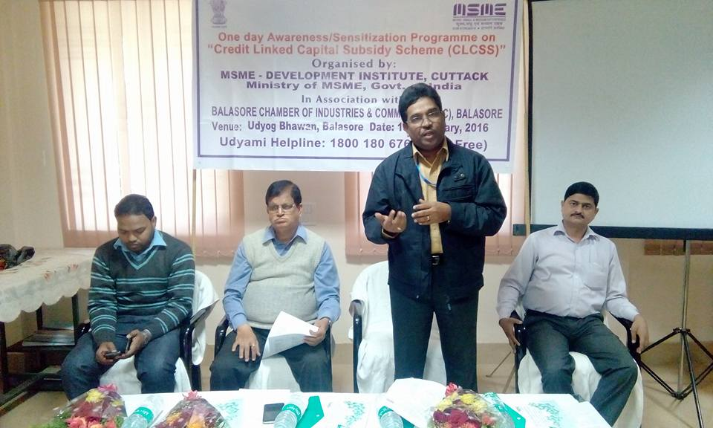  One day seminar on Awareness/Sensitization Program On Credit Linked Subsidy Scheme (SlCSS) was organized in association of Balasore Chamber of Industries and Commerce in the conference hall of Udyog Bhawan by MSME development Institute, Government of India, Cuttack. Sri B.N.Guru, Asst. Director (EI) of MSMEDI, Cuttack presented the back ground paper on the topic and well come all the participants. Then the officer from SIDBI, Bhubaneswar has described the scheme in detail followed by interaction session. All the entrepreneurs present have clarified their doubts. Sri Guru requested the eligible entrepreneurs should avail this facility in order to strengthen their industrial growth. Sri Himanshu Das appreciated the steps taken by MSME-DI Cuttack to bring all the schemes to doorstep of entrepreneurs so that they will clearly understood the scheme and avail the opportunity.
21.01.2016 | SEMINAR ON ENERGY EFFICIENT TECHNOLOGY  One day seminar was organized by MSME Development Institute, Govt. of India, Cuttack on Energy Efficient Technologies in association with Energy and Resource Institute, New-Delhi and Balasore Chamber of Industries and Commerce in the conference hall of Udyog Bhawan on 21.01.2016 Sri Himanshu Das presided over the meeting and well come all the Guests and participants and requested the participant specially from Rice Milling sector to adopt and utilized this in order to enhance competitiveness of their unit in the market for their sustainable growth.. Sri C.P. Reddy, Asst. Director (G&C), MSMEDI, Cuttack has presented the background paper on the topic and requested that by adopting Energy Efficient Technologies in their manufacturing process and encouraged them towards acquiring product quality certification to National/International standards.. Then the Resource person from Energy and Resource Institute, New-Delhi presented a wide range of details on the subject and benefit out of this. He clarified further details during interaction session.
26.02.2016 | SEMINAR ON “TOTAL QUQLITY OF LIFE AND DILUTION OF STREES  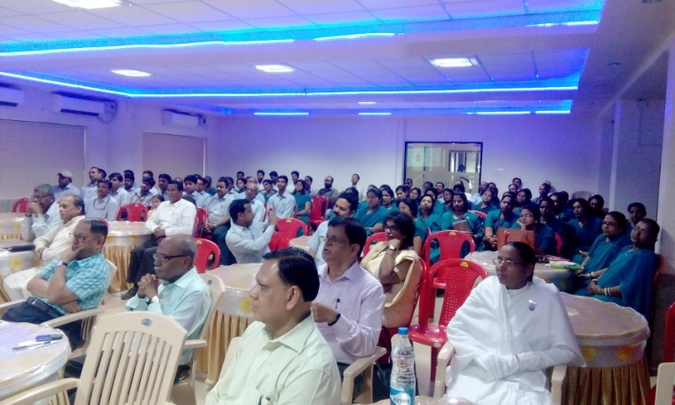  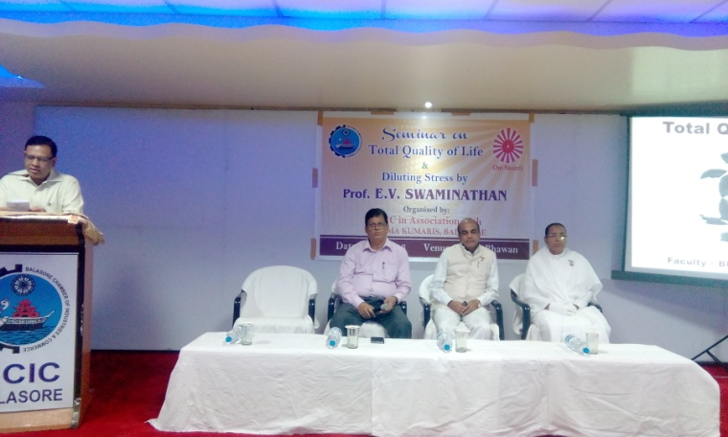  Seminar on “TOTAL QUALITY OF LIFE AND DILUTION OF STREES” was organized by Balasore Chamber of Industries and Commerce in association with Prajapita Brahmakumari, Balasore in the conference hall of Udyog Bhawan on 24th February,2016 at 10.30 AM Prof. E.V.Swaminatan, from Mumbai has presented a detail deliberation on the topic with some demonstrations what is life and given some tips how the stress can be diluted. More than 100 Participants are from Industries, trade and service sectors have attended . Sri Himanshu Das, President of the Chamber presided over the meeting and well come all for participating such program. Sri Sunuil Modi General Secretary of the Chamber Introduced the Guest and lastly presented vote of thanks to all.

****************

